REAL-TIME CAPSTONE PROJECT : RETAIL SALES & CUSTOMER INSIGHTS



Submitted by:
Thiageshwaran S
ADMM
Technology and Transformation

March 2026
RETAIL SALES & CUSTOMER INSIGHTS
1. Business Problem Statement
1.1 Background
The retail chain operates across multiple regions and manages a diverse customer base along with a wide range of product categories. Due to increasing data volume and operational complexity, the organization faced challenges in transforming raw transactional data into actionable business insights.
The absence of a centralized analytics system limited visibility into performance metrics, customer behavior patterns, and regional trends.
1.2 Key Business Challenges
1.2.1 Identifying Top-Performing Products
Management lacked clarity on:
- Which products generate the highest revenue
- Which categories drive the majority of sales
- Which products should be promoted, optimized, or discontinued
1.2.2 Understanding Complex Purchasing Patterns
Retail purchasing behavior is influenced by multiple factors:
- Seasonality (monthly and quarterly trends)
- Promotional campaigns
- Customer demographics (region and gender)
Without structured analysis, it was difficult to detect patterns, repeat purchase behavioror revenue concentration.
1.2.3 Visualizing Regional Sales Trends
Regional insights were required for:
- Inventory optimization
- Marketing strategy alignment
- Supply chain planning
- Performance benchmarking
However, inconsistent and unstructured data prevented meaningful regional comparison.
2. Project Objectives – KPIs and Goals
2.1 Primary Objectives
The primary objectives of the project were:
- Design and implement a structured Data Warehouse
- Develop meaningful business KPIs
- Create an executive-level Power BI dashboard
- Enable interactive drill-down analytics
2.2 Key Performance Indicators (KPIs)
The following KPIs were defined and implemented:
- Total Sales Revenue
- Sales Growth Rate
- Previous Period Sales
- Total Quantity Sold
- Customer Count
- Average Transaction Value (ATV)
- Customer Lifetime Value (CLV)
- Revenue Per Customer
- Total Product Sales
2.3 Strategic Goals
- Identify revenue-driving products
- Analyze seasonal and regional sales trends
- Evaluate customer lifetime value
- Support executive decision-making through visual analytics
3. ETL Process Using Python and Microsoft SQL Server
3.1 Tools and Technologies Used
- Python (Pandas, SQLAlchemy, PyODBC)
- Jupyter Notebook
- Microsoft SQL Server
- SQL Server Management Studio (SSMS)
3.2 Data Sources
S.No | Data Source | Format
1 | Customer Data | JSON
2 | Product Data | CSV
3 | Sales Data | CSV

3.3 ETL Architecture
The ETL pipeline followed a structured approach:
- Extract – Load raw data into Python
- Transform – Clean, normalize, and validate data
- Load – Insert cleaned data into SQL Server Data Warehouse
3.4 Extraction Phase
Customer data was extracted from JSON files.
Product and sales data were extracted from CSV files using Pandas.Data was loaded into DataFrames for transformation.
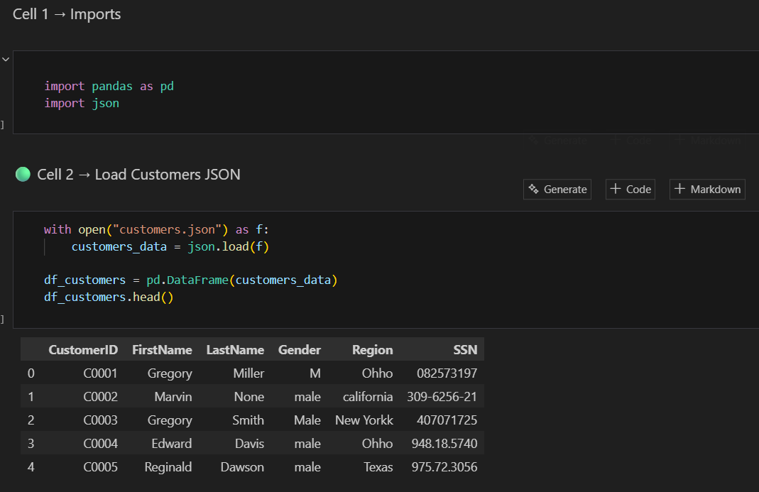
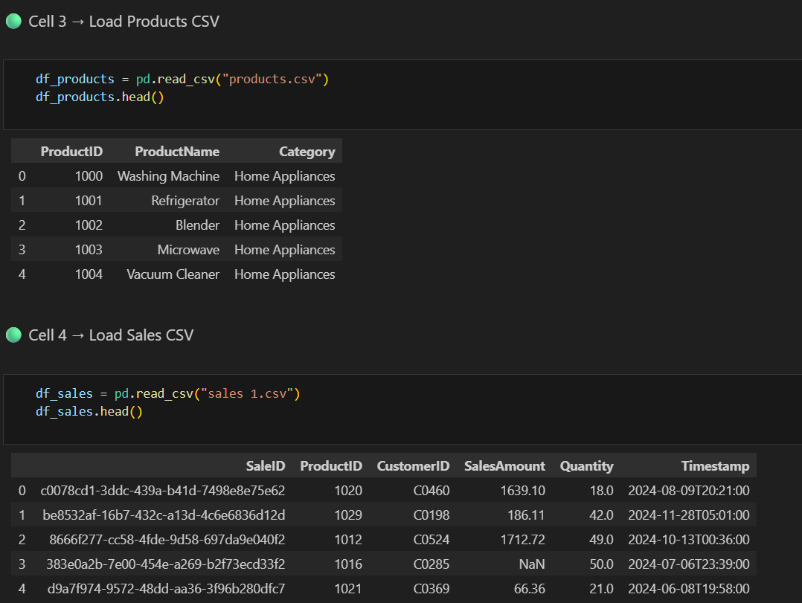
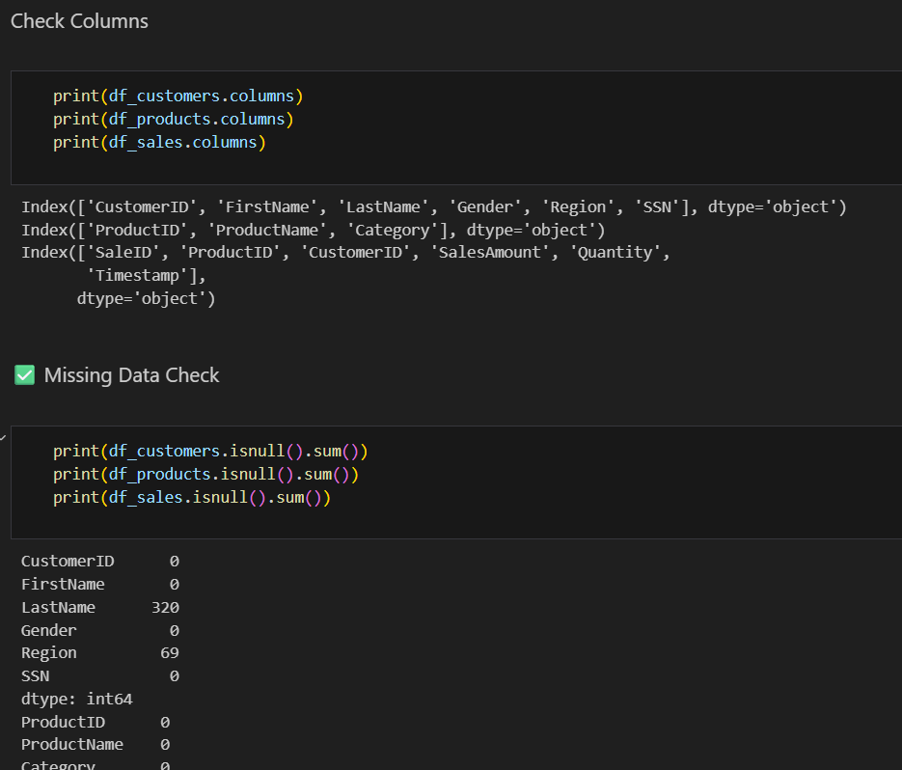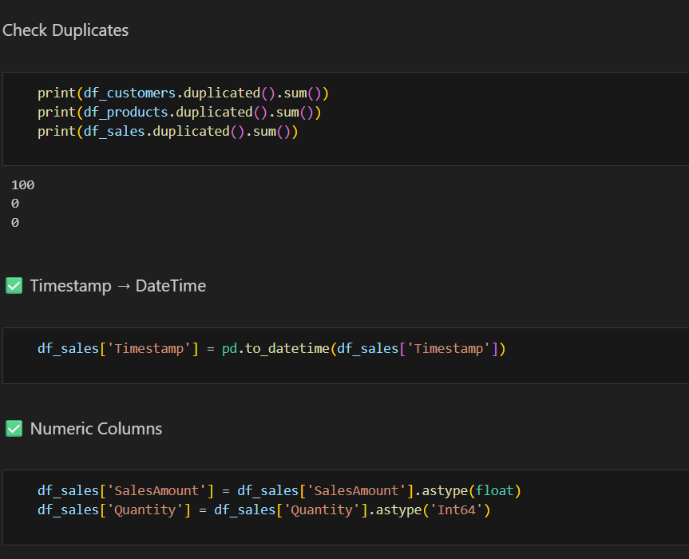
3.5 Transformation Phase
This phase involved extensive data cleaning and validation.
3.5.1 Issues Identified and Resolutions
Issue 1: CustomerID Format Mismatch
Customer IDs were in the format : C0001
SQL schema expected integer values.
Resolution:
Extracted numeric portion and converted to integer.
Issue 2: Region Inconsistencies
Examples identified:
- Nw York
- New Yorkk
- Ny
- Californiya
- Texaz
- Ohho
Resolution:
- Trimmed whitespace
- Standardized case
- Replaced incorrect spellings
- Applied consistent naming conventions
Issue 3: Duplicate Primary Keys
Error encountered during loading:
Violation of PRIMARY KEY constraint.
Root Cause: Duplicate CustomerID entries after transformation.
Resolution:
Removed duplicate records using Pandas before loading.
Issue 4: Data Type Conversion Errors
Conversion failed when inserting varchar into integer columns.
Resolution:
Aligned SQL schema with cleaned data types and validated data prior to loading.
Issue 5: Foreign Key Constraints Blocking Table Replacement
Attempting to replace dimension tables caused foreign key constraint errors.
Resolution:
Followed proper loading order:
- Drop Fact table
- Drop Dimension tables
- Recreate tables
- Load Dimension tables first
- Load Fact table last
This preserved referential integrity.
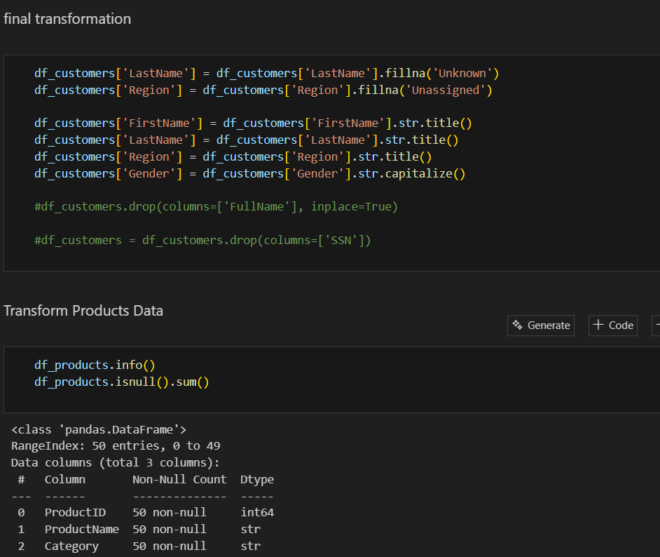
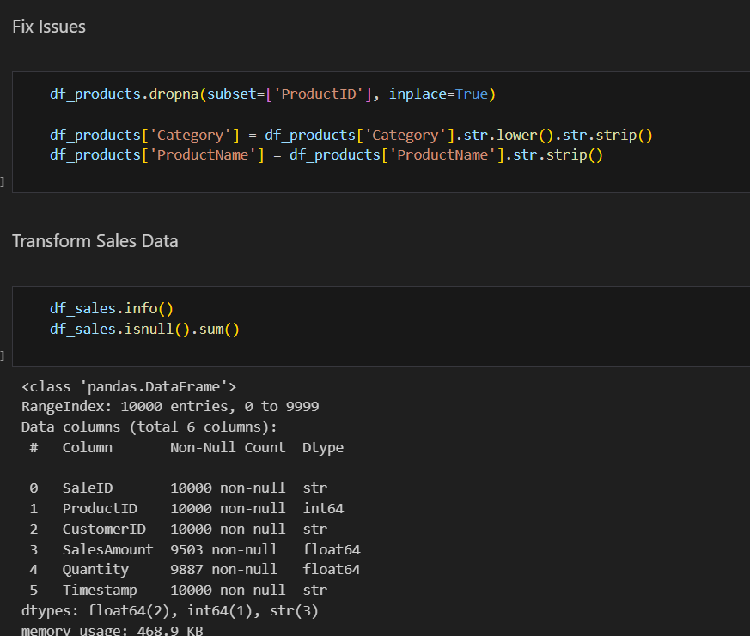
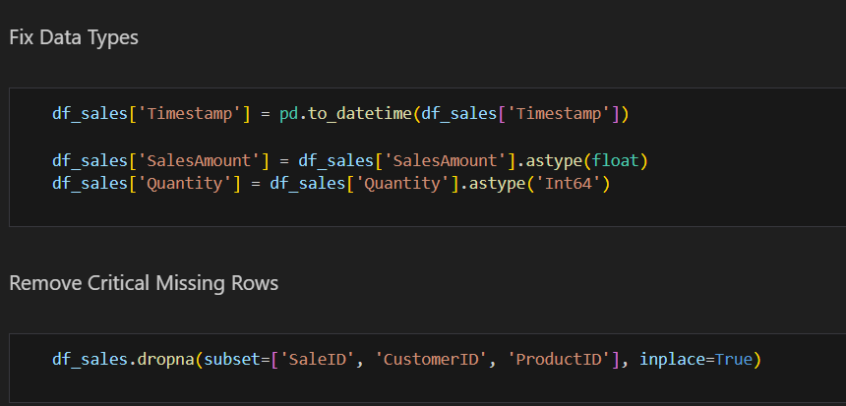
3.6 Loading Phase
Data was loaded into SQL Server using SQLAlchemy.
Load Order:
- DimCustomer
- DimProduct
- DimDate
- FactSales
This ensured consistent foreign key relationships.
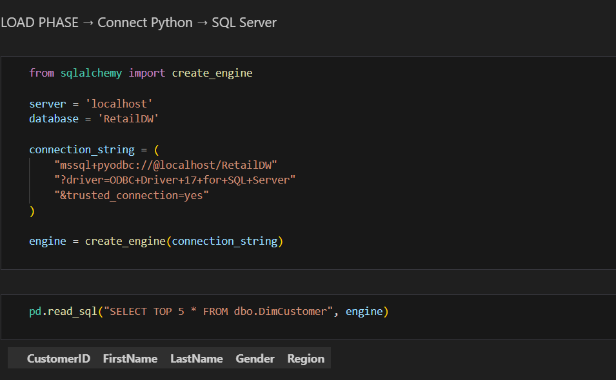
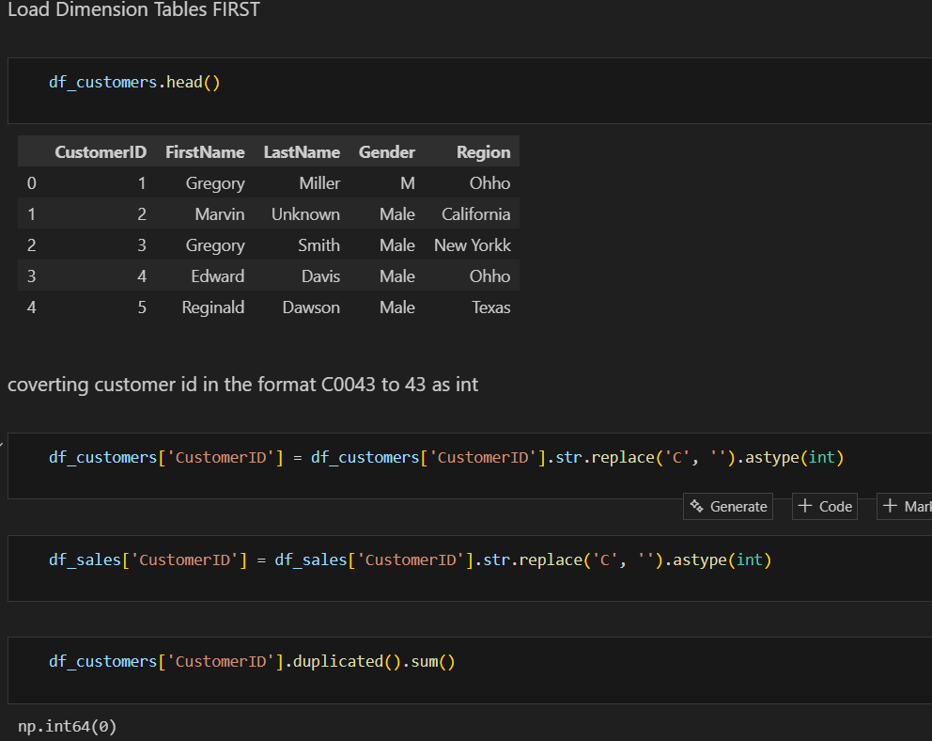

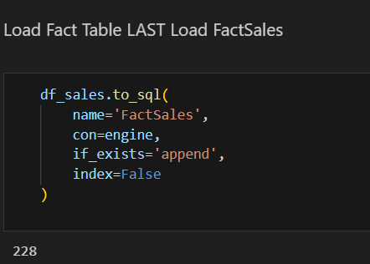
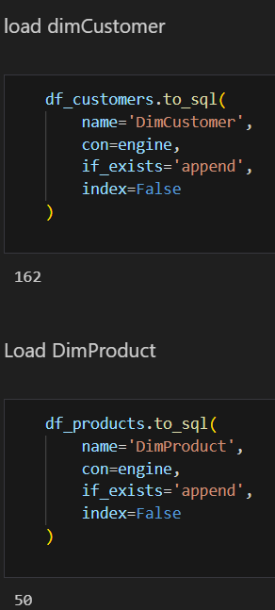

4. Exploratory Data Analysis and Data Warehouse Design
4.1 Exploratory Data Analysis (EDA)
EDA was performed to:
- Check null values
- Validate primary and foreign keys
- Analyze sales distribution
- Detect seasonal patterns
- Identify data inconsistencies
Key Findings:
- Monthly sales variation indicating seasonality
- Region inconsistencies
- Missing values in certain customer attributes
- Skewed revenue distribution among products
SQL CODE:
USE RetailDW;
CREATE TABLE DimCustomer (
CustomerID INT PRIMARY KEY,
FirstName VARCHAR(50) NOT NULL,
LastName VARCHAR(50) NOT NULL,
Gender VARCHAR(10),
Region VARCHAR(50)
);
CREATE TABLE DimProduct (
ProductID INT PRIMARY KEY,
ProductName VARCHAR(100) NOT NULL,
Category VARCHAR(50) NOT NULL
);

CREATE TABLE DimDate (
DateKey INT PRIMARY KEY,
FullDate DATE NOT NULL,
Year INT,
Quarter INT,
Month INT,
Day INT
);

CREATE TABLE FactSales (
SaleKey INT IDENTITY PRIMARY KEY,
SaleID VARCHAR(50), -- UUID Business Key
ProductID INT,
CustomerID INT,
SalesAmount DECIMAL(10,2) NOT NULL,
Quantity INT NOT NULL,
Timestamp DATETIME NOT NULL,

FOREIGN KEY (ProductID) REFERENCES DimProduct(ProductID),
FOREIGN KEY (CustomerID) REFERENCES DimCustomer(CustomerID)
);

SELECT * FROM DimCustomer;
SELECT * FROM DimProduct;
SELECT * FROM DimDate;
SELECT * FROM FactSales;

DROP TABLE FactSales;
DROP TABLE DimCustomer;

ALTER TABLE FactSales
ALTER COLUMN SalesAmount FLOAT NULL;

ALTER TABLE FactSales
ALTER COLUMN Quantity INT NULL;

SELECT COUNT(*) FROM dbo.DimCustomer;
SELECT COUNT(*) FROM DimProduct;
SELECT COUNT(*) FROM FactSales;
SELECT * FROM dbo.DimCustomer;
SELECT TOP 10 * FROM FactSales;

SELECT TOP 10 * FROM DimCustomer;
SELECT TOP 10 * FROM DimProduct;

-- KPI 1 → Total Sales Revenue
SELECT
SUM(SalesAmount) AS TotalRevenue
FROM FactSales;

-- KPI 2 → Total Units Sold
SELECT
SUM(Quantity) AS TotalUnitsSold
FROM FactSales;

-- KPI 3 → Top-Selling Products
-- (Which products generate most revenue?)
SELECT
p.ProductName,
SUM(f.SalesAmount) AS Revenue
FROM FactSales f
JOIN DimProduct p
ON f.ProductID = p.ProductID
GROUP BY p.ProductName
ORDER BY Revenue DESC;

-- KPI 4 → Sales by Category
-- Which category performs best?
SELECT
p.Category,
SUM(f.SalesAmount) AS Revenue
FROM FactSales f
JOIN DimProduct p
ON f.ProductID = p.ProductID
GROUP BY p.Category
ORDER BY Revenue DESC;

--KPI 5 → Sales by Region
-- Which regions drive revenue?
SELECT
c.Region,
SUM(f.SalesAmount) AS Revenue
FROM FactSales f
JOIN DimCustomer c
ON f.CustomerID = c.CustomerID
GROUP BY c.Region
ORDER BY Revenue DESC;

-- KPI 6 → Average Transaction Value (ATV)
SELECT
SUM(SalesAmount) / COUNT(SaleID) AS AvgTransactionValue
FROM FactSales;

-- KPI 7 → Monthly Sales Trend
SELECT
YEAR(Timestamp) AS Year,
MONTH(Timestamp) AS Month,
SUM(SalesAmount) AS Revenue
FROM FactSales
GROUP BY
YEAR(Timestamp),
MONTH(Timestamp)
ORDER BY Year, Month;

-- Best-Selling Products by Quantity

SELECT
p.ProductName,
SUM(f.Quantity) AS UnitsSold
FROM FactSales f
JOIN DimProduct p
ON f.ProductID = p.ProductID
GROUP BY p.ProductName
ORDER BY UnitsSold DESC;

-- Sales Growth Rate
-- How fast are sales increasing or decreasing?
WITH MonthlySales AS (
SELECT
YEAR(Timestamp) AS Year,
MONTH(Timestamp) AS Month,
SUM(SalesAmount) AS Revenue
FROM FactSales
GROUP BY
YEAR(Timestamp),
MONTH(Timestamp)
)
SELECT *,
LAG(Revenue) OVER (ORDER BY Year, Month) AS PreviousRevenue,

(Revenue - LAG(Revenue) OVER (ORDER BY Year, Month)) * 100.0
/ LAG(Revenue) OVER (ORDER BY Year, Month)
AS GrowthRatePercent

FROM MonthlySales;

-- Customer Lifetime Value (CLV)

SELECT
c.CustomerID,
c.FirstName,
c.LastName,
SUM(f.SalesAmount) AS CustomerLifetimeValue
FROM FactSales f
JOIN DimCustomer c
ON f.CustomerID = c.CustomerID
GROUP BY
c.CustomerID,
c.FirstName,
c.LastName
ORDER BY CustomerLifetimeValue DESC;

-- Product Return Rate
SELECT
p.ProductName,

SUM(CASE WHEN f.Quantity < 0 THEN ABS(f.Quantity) ELSE 0 END) * 100.0
/ SUM(ABS(f.Quantity))
AS ReturnRatePercent

FROM FactSales f
JOIN DimProduct p
ON f.ProductID = p.ProductID

GROUP BY p.ProductName;
4.2 Data Warehouse Design
A Star Schema architecture was implemented.
4.2.1 Fact Table
Fact Sales:
- SaleID
- CustomerID
- ProductID
- SalesAmount
- Quantity
- Timestamp
4.2.2 Dimension Tables
- DimCustomer
- DimProduct
- DimDate
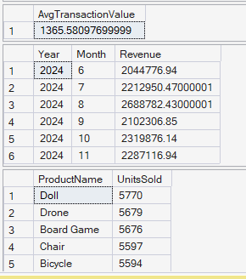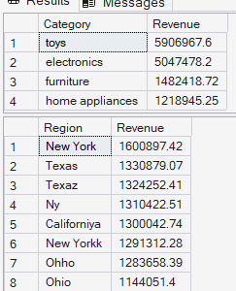
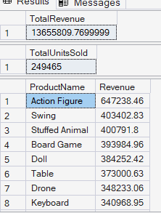
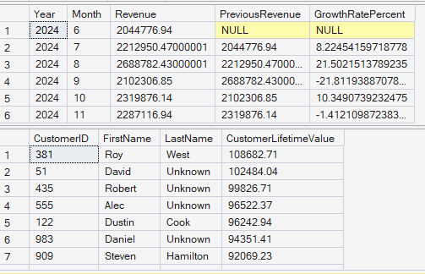
4.3 Staging Area
Raw data was initially loaded into staging tables.
After validation and transformation, cleaned data was loaded into dimensional tables.
4.4 Rationale for Star Schema
- Optimized for BI queries
- Simplified reporting structure
- Improved performance
- Clear separation of measures and attributes
5. Power BI Implementation
5.1 Data Preparation
Connected Power BI to SQL Server database (RetailDW).
Import mode was used.
Loaded tables:
- FactSales
- DimCustomer
- DimProduct
- DimDate
Power Query was used for additional cleaning:
- Trim
- Replace values
- Standardize region names
- Correct data types
5.2 Data Modeling
Relationships defined:
- FactSales → DimCustomer (Customer ID)
- FactSales → DimProduct (Product ID)
- FactSales → DimDate (Date)
Relationship Type:
- One-to-Many
- Single-direction filter
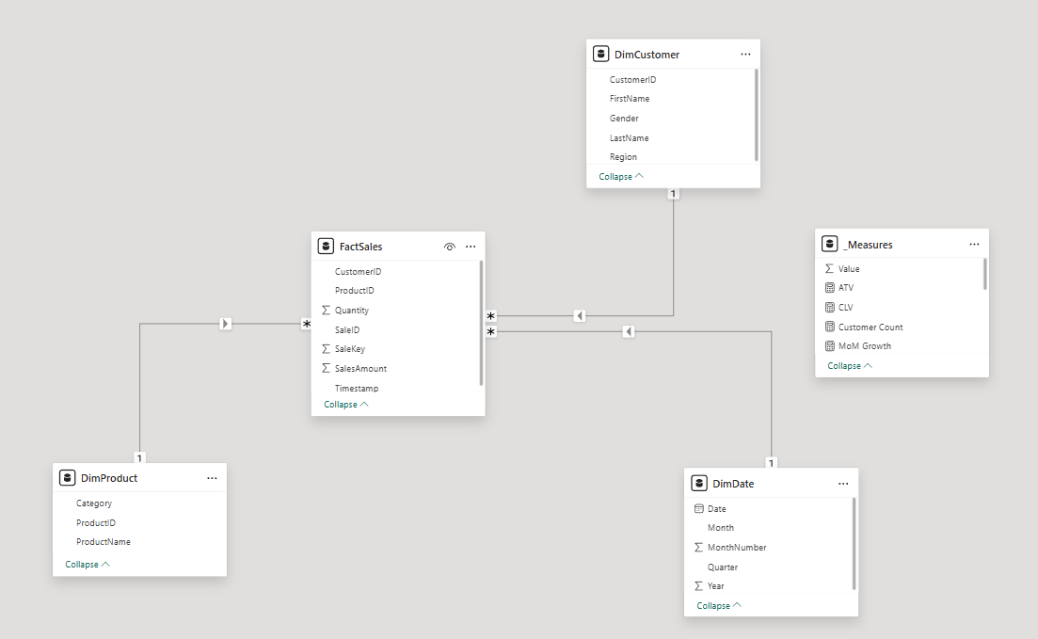
5.3 KPI Measures (DAX Implementation)
Examples include:
Total Sales Revenue
Sales Growth Rate
Customer Lifetime Value
Revenue Per Customer
Average Transaction Value
Advanced measures included:
- Previous Period Sales
- Growth Percentage
- Repeat Purchase Rate

Total Sales Revenue
Total Sales Revenue =
SUM(FactSales[SalesAmount])

Total Quantity Sold
Total Quantity Sold =
SUM(FactSales[Quantity])

Customer Count
Customer Count =
DISTINCTCOUNT(DimCustomer[CustomerID])

Total Product Sales
Total Product Sales =
SUM(FactSales[SalesAmount])

Revenue Per Customer
Revenue Per Customer =
DIVIDE(
[Total Sales Revenue],
[Customer Count]
)

Average Transaction Value (ATV)
ATV =
DIVIDE(
[Total Sales Revenue],
DISTINCTCOUNT(FactSales[SaleID])
)

Previous Period Sales
Previous Period Sales =
CALCULATE(
[Total Sales Revenue],
SAMEPERIODLASTYEAR(DimDate[Date])
)

Sales Growth Rate
Sales Growth Rate =
DIVIDE(
[Total Sales Revenue] − [Previous Period Sales],
[Previous Period Sales]
)

Customer Lifetime Value (CLV)
CLV =
DIVIDE(
[Total Sales Revenue],
[Customer Count]
)
5.4 Dashboard Development
A four-page professional dashboard was created:
- Executive Overview
- Sales Performance Analysis
- Customer Intelligence
- Product and Category Insights
Features implemented:
- KPI cards
- Trend analysis charts
- Regional comparison visuals
- Slicers and filters
- Drill-through pages
- Dynamic titles
- Custom tooltip pages
- Smart narrative insights
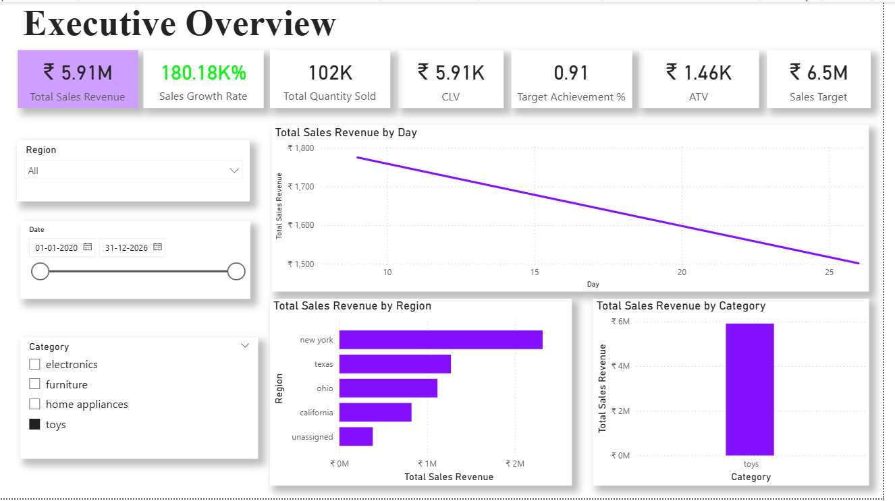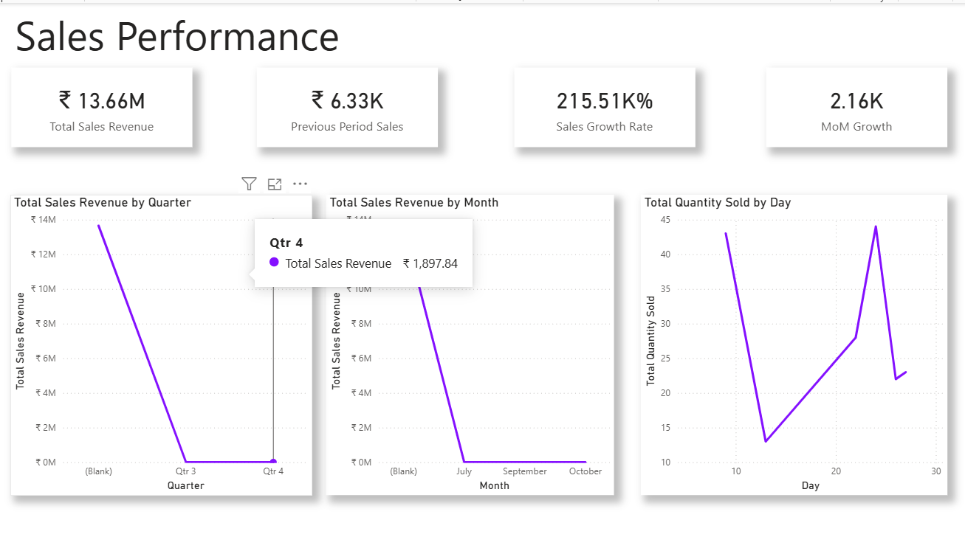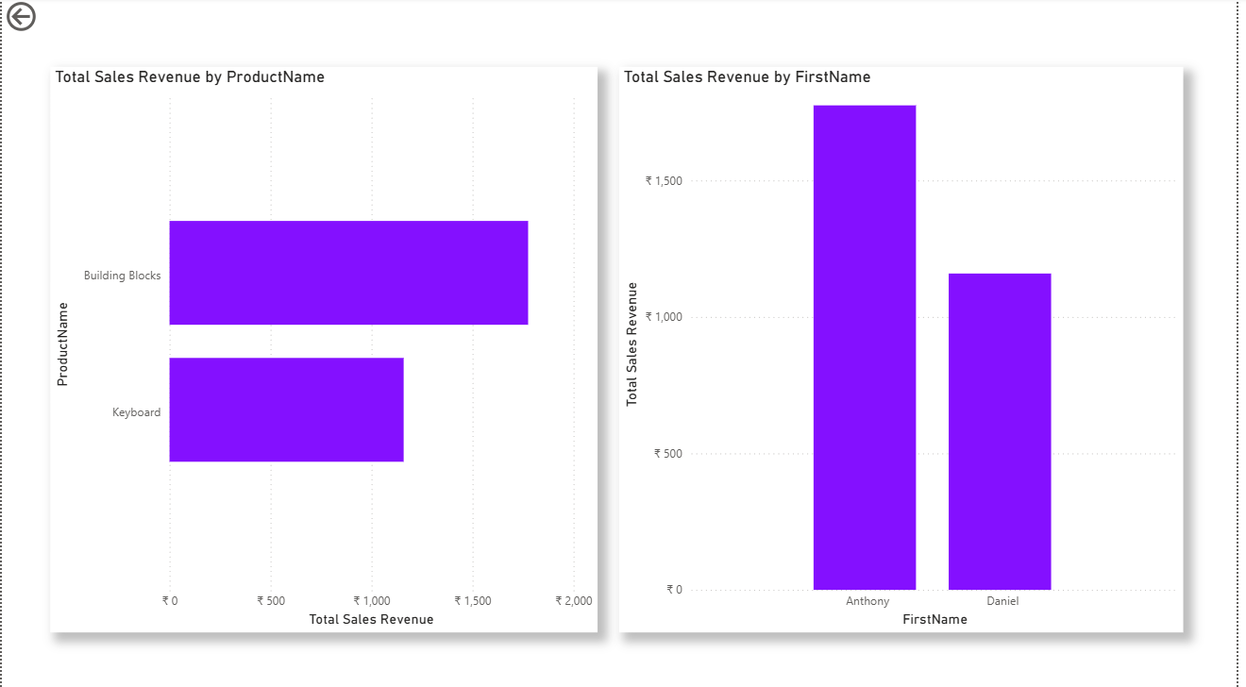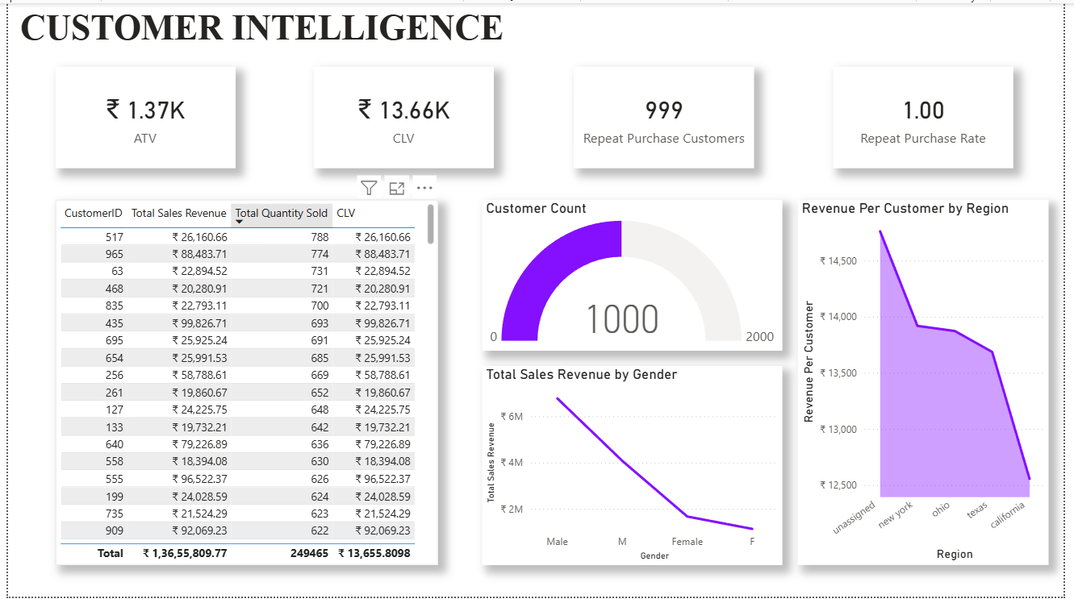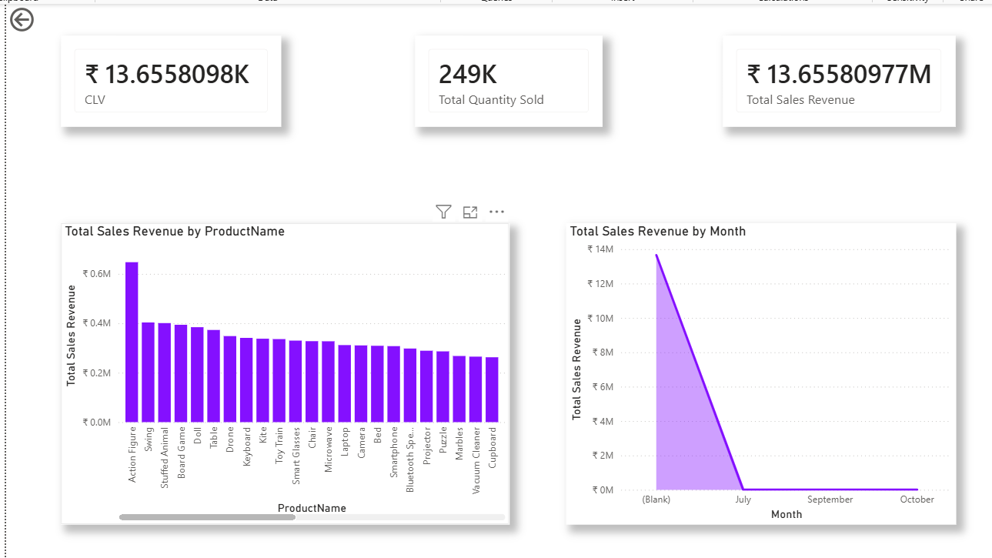

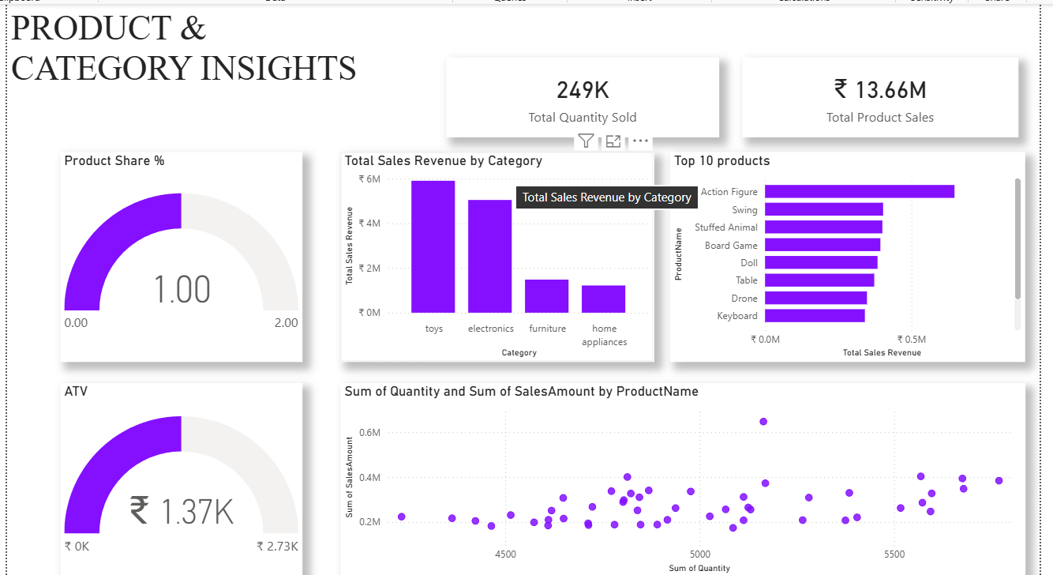

6. Challenges Faced and Resolutions
S.No | Challenge | Resolution
1 | CustomerID format mismatch | Extracted numeric portion
2 | Duplicate primary keys | Removed duplicates
3 | Region inconsistencies | Standardized values
4 | Foreign key drop errors | Correct table load order
5 | Blank growth metrics | Corrected time-intelligence logic
6 | Empty DimDate table | Generated proper date dimension

7. Project Outcome
The project delivered:
- A structured Data Warehouse
- Clean and validated retail dataset
- Business-aligned KPI framework
- Executive-ready Power BI dashboard
The solution enables:
- Performance monitoring
- Customer behavior analysis
- Product optimization decisions
- Regional sales tracking
- Data-driven strategic planning

8. Conclusion
This project demonstrates the complete lifecycle of a Business Intelligence solution:
- Data Engineering (ETL & SQL)
- Data Modeling (Star Schema Design)
- Analytical Computation (DAX KPIs)
- Visualization (Power BI Dashboard)
Raw retail data was successfully transformed into a centralized, structured, and actionable analytics system.

